**STEPS**

1. Open the Visual C++ and click the New item in the File Menu and a new dialog box is opened
2. Now select “MFC AppWizard (exe)” entry
3. Give the new Project name in the Project name box and click OK. By clicking OK will start the Visual C++ AppWizard

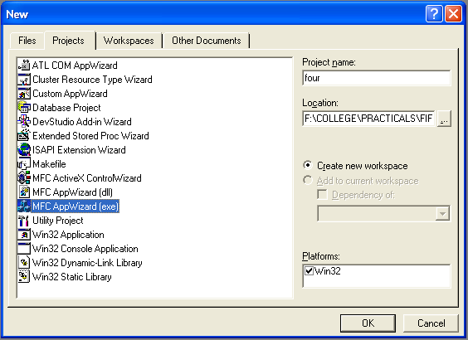

1. We will accept all defaults except one- by default, AppWizard creates Multiple Documents program and we will change so that it creates a Single Document program

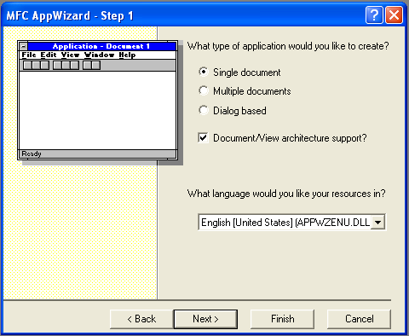

1. Click the option marked “Single Document” in AppWizard and click Next
2. The AppWizard will ask what Database we want in our program; we will select “None” option. Keep pressing Next until project information box is opened
3. The AppWizard will create following classes:

* CfourApp
* CfourDoc
* CfourView
* CMainFrame

1. Click OK button in New Project Information box to create the project
2. Click the ClassView tab in the Visual C++ and find the entry for the CfourView class
3. Click the small ‘+’ next to the entry to open it. This will display the methods in this class
4. Find the entry for the OnDraw() method, and double click it. This opens OnDraw() method in the text editor
5. To customize our program, add these lines of code:

void CFourView::OnDraw(CDC* pDC)

{

* CString a="Welcome To The World Of Visual C++";

CFourDoc* pDoc = GetDocument();

ASSERT_VALID(pDoc);

* pDC->TextOut(0,0,a);

// TODO: add draw code for native data here

}

1. Now the program is ready. Run it by choosing the “Build four.exe” item in the Build Menu, followed by “Execute four.exe” in the same menu

**OUTPUT**

